Upskillfy Course Creation SOP
A step by step guide for tutors
Use this guide to create your course, add your lessons and send the course to Upskillfy for review. Work through the steps in order. You do not need previous course creation experience.

Before you start
Have these ready on your phone or computer:
• Your tutor account and a stable internet connection.
• A course title, a description and a list of what learners will be able to do.
• A course cover image, lesson images, videos, written lessons and any supporting documents you plan to include.
• An outline of your sections and lessons, with the length of each lesson.
• Your price, or a decision to offer the course for free. If you will issue certificates, prepare a public link to the assessment document.

Open the course builder
1. Sign in to Upskillfy with your tutor account and open your tutor dashboard.
2. On the mobile dashboard, tap More at the bottom of the screen.
3. Tap New course. The Create Course form opens at Basics.
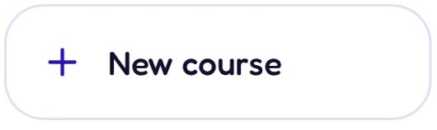
Select New course from the More menu.
You can also open the course creation page after signing in.

How to use this guide
The five stages are Basics, Listing, Curriculum, Pricing & access, and Review & publish. Tap Continue to move forward and Back to return to an earlier stage.
The examples use a course called Leadership fundamentals. Replace the example details and files with your own. On a phone, close the keyboard and scroll down if a button is hidden.

Step 1 Add the basics
The Basics page describes your course and helps learners find it. Complete the fields from top to bottom.
Field | What to enter | Example
Course Title | A clear name that tells learners what you teach. | Leadership fundamentals
Category | Choose the subject area that best fits the course. | Career Development
Language | Choose the language used in your lessons. | English
Level | Choose Beginner, Standard or Pro to match your learners. Use Beginner for an introductory course. | Beginner
Total length | Enter the length of the whole course and choose the correct unit. | 3 hours
Tags | Type one relevant keyword, then press Enter. Repeat to add another keyword. | leadership  communication

For tags: enter each word or phrase separately. After pressing Enter, it appears as a coloured label. Tap its × if you need to remove it.
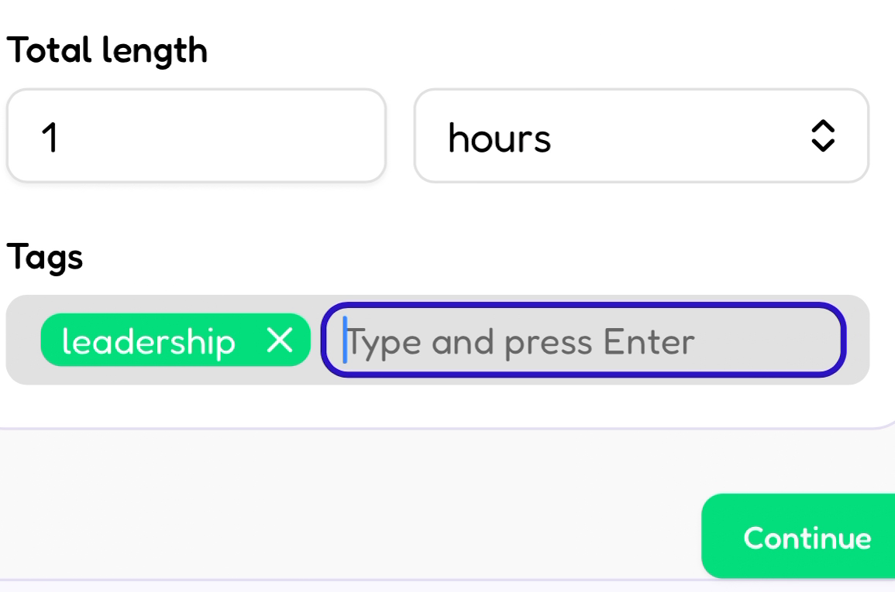
Add the total course length, then enter each tag and press Enter.
1. Check the title, subject, language, level and length. The course length should agree with the lessons you plan to add.
2. Tap Continue. If a field shows an error, correct that field and try again.
You are ready to move on when: the Listing page opens.

Step 2 Create the course listing
The Listing page is what learners read before choosing your course. Explain who it is for and what they will learn.
1. Under Cover image, tap the upload area and choose your course image. Use a JPG or PNG at least 600 × 450 pixels. Upskillfy crops it to a 4:3 shape, so keep important words and faces away from the edges.
2. Check the image preview. Use Replace to choose a different image or Remove to clear it.
3. Under What learners will be able to do, enter one learning outcome. Tap Add an outcome for each additional outcome, up to six. Use the minus button to remove an unwanted row.
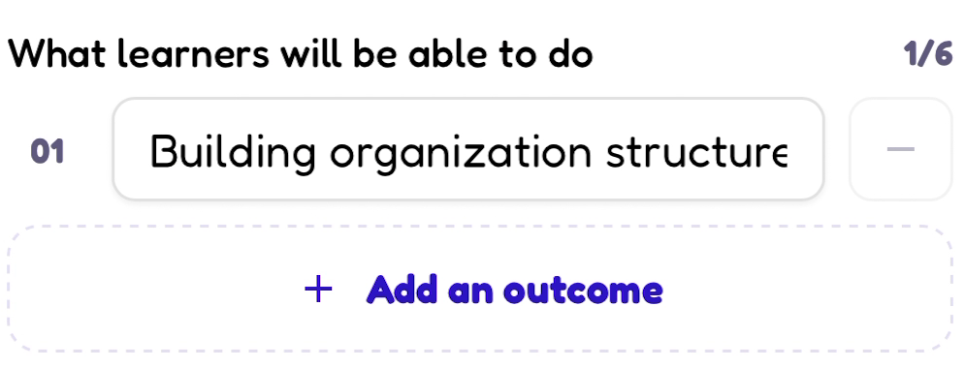
Write one outcome per row. Add an outcome creates another row.
Outcome examples: “Give clear feedback to a team member” and “Create a simple team structure.” Describe an action the learner will be able to perform.
4. In Full Description, explain who should take the course, what you cover, what learners need beforehand and how they will practise. This field is required. If you see Description Is Too Short, add a fuller explanation.

Example description
Leadership fundamentals is for students and new team leaders who want to manage people with more confidence. You will learn about emotional intelligence, communication and team structure. The course includes video lessons, written explanations and practical exercises. You will practise giving feedback and planning how a small team works. No previous leadership experience is needed. Bring a notebook and be ready to complete the activities.
5. Read the listing once more, then tap Continue and wait for the Curriculum page to open.
Before you move on: check that your cover, outcomes and description all describe the same course.

Step 3 Organise your lessons
The Curriculum is your course outline. A section is a group of related lessons, like a chapter. A topic is one lesson inside that section.

Create your first section
1. Tap Add your first section. Enter a Section Title, such as “Emotional intelligence”, then tap Save.
2. When the section appears, tap its title to open it, then tap Add Topic to create its first lesson.
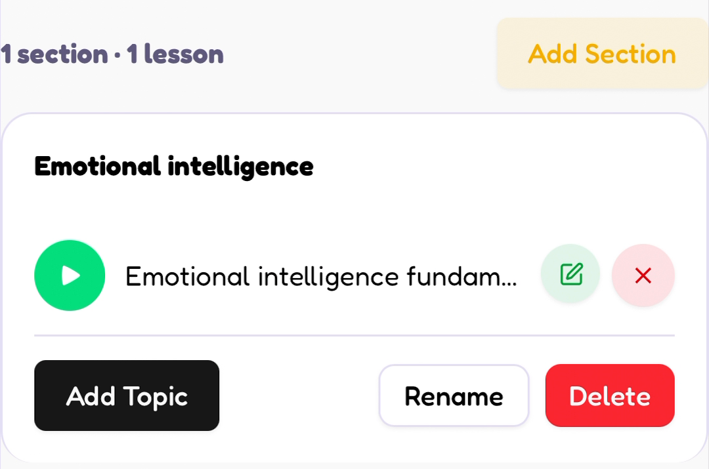
A section contains lessons. Add Topic adds another lesson to that section.

Fill in the lesson details
In the Create Topic form, complete these fields. Scroll inside the form to reach the lower fields.
Field | What to enter
Title | The name of this lesson, such as Emotional intelligence fundamentals.
Lesson Description | A short summary of what this lesson teaches. The box may show Enter Keywords before you type.
Thumbnail | Tap Choose File and select the image for this lesson.
Level | Select the level that fits this lesson.
Duration | Enter this lesson’s Hours and Minutes. For a 15 minute lesson, enter 0 hours and 15 minutes.

Keep the form open. Next, choose the lesson type and add its content, as shown on the next page.

Step 3 Add content and save each lesson
In Type, choose the format you want learners to use.
Type | Content to add
Text | Write the lesson in Add Description.
Video | Add the lesson video under Source.
Both | Write in Add Description and add a video under Source.

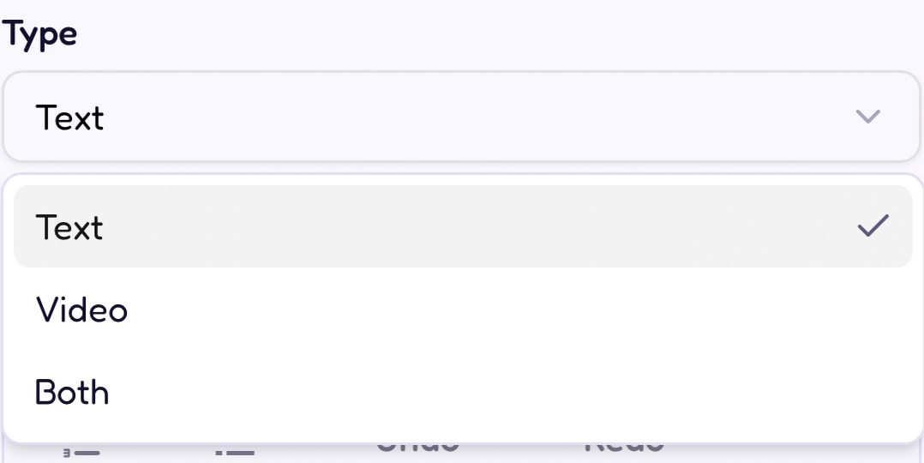
Choose Text, Video or Both for each lesson.
1. For Text or Both, enter your teaching content in Add Description. Use paragraphs or lists to make it easy to read. This is the written lesson; the earlier Lesson Description is its short summary.
2. For Video or Both, go to Source, choose File, tap Choose File and select your lesson video. On a phone, choose Photo Library or Choose File, depending on where you saved it. Each video can be up to 500MB.
The Source area also offers Link for a video URL. Use the file upload steps above when your video is saved on your device.
3. To include a handout or worksheet, go to Document, tap Choose File and select it. Accepted formats are PDF, DOC, DOCX, TXT, PPT, PPTX, XLS and XLSX, up to 100MB.
4. Tap Save Topic. Keep the page open while the upload percentage increases. Wait until the form closes and the lesson appears inside its section.
Check that it saved: your lesson title appears and the lesson count increases. Use the pencil icon beside a lesson to make a correction.

Repeat until the course is complete
Use Add Topic for the next lesson in the same section. Use Add Section for another group of lessons. Add every planned lesson before tapping Continue. Upskillfy suggests 3 to 6 sections for most courses; organise yours around what you need to teach.

Step 4 Set the price and certificate options
On Pricing & access, decide what learners will pay and whether the course will offer a certificate.
1. Under Course type, choose Paid or Free. For a paid course, enter your amount in Price. The price field uses Nigerian naira (₦). For example, enter 20000 for ₦20,000. Set your own course price.
2. Under Certificate on completion, choose Yes if you will issue a certificate, or No if you will not.
3. If you choose Yes, paste a public link to your assessment in Assessment document. An assessment is the task or test learners complete to demonstrate what they have learned.
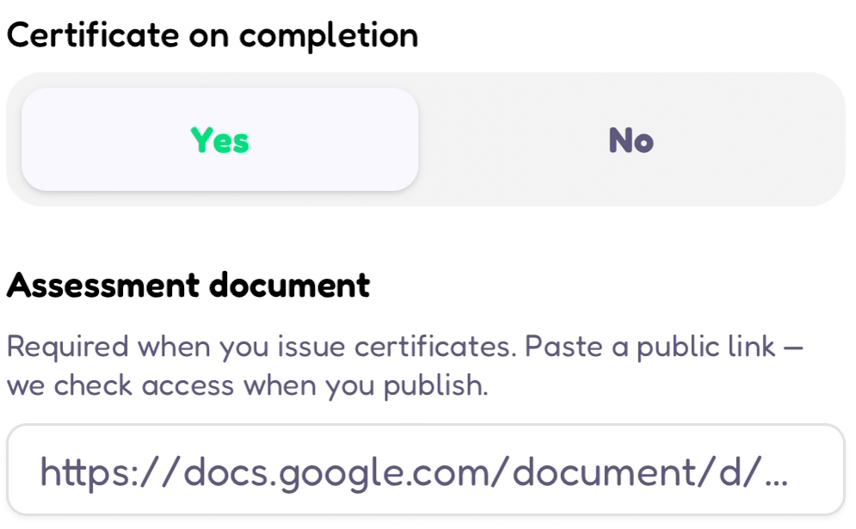
A certificate course needs a public assessment link in this field.

Make sure the assessment link opens
Prepare the assessment document, enable access for anyone with the link, then copy its sharing link. Test it in a private browser window to check that it opens without asking for permission. Paste that link into Upskillfy. The platform says it checks access when you publish.
4. If your course includes a mentorship link, enter it in Mentorship Link. If you are unsure which link to use, ask your Upskillfy contact.
5. Check your price and certificate choice, then tap Continue to open Review & publish.
Before you move on: choosing Yes for certificates means you need to provide the assessment link. Do not leave the sample link or placeholder text as your answer.

Step 5 Check the course and submit it
Use Review & publish to check the course before sending it to the Upskillfy team.
1. Read Ready to submit. If you see Basics incomplete, tap Back until you reach Basics, correct the missing details, then use Continue to return to the review page. If you see Assessment link missing for a certificate course, tap Add link and provide the public assessment link.
2. Check the section and lesson counts. Use Edit to return to the curriculum if you need to add or correct a lesson. Review the course preview, including its title, cover, level and price.

Final checklist
• The course title, category, language, level and total length are correct.
• The cover image, learning outcomes and full description are complete.
• Every planned lesson appears in the correct section with its content saved.
• Lesson titles, durations, videos and documents match what you intend to teach.
• The price and certificate choice are correct. Any required assessment link opens without a permission request.
3. Optional: use Add question in the FAQ area to add answers to common learner questions, such as whether prior experience is needed. You can leave the FAQ area empty.
4. Tap Submit for review once, then wait for the confirmation Submitted for review!
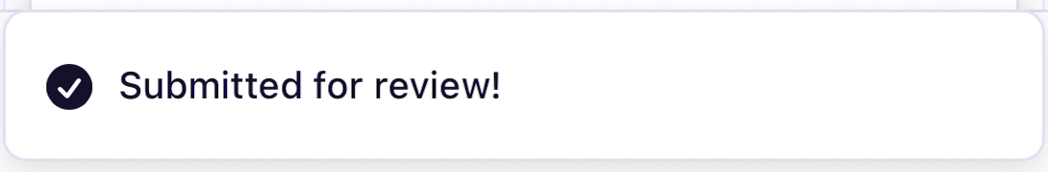
This message confirms that Upskillfy received the course for review.

What happens next
Your course has been sent for review. Approval is a separate step. The Upskillfy admin team reviews within 3 days and emails you either way. The course remains editable until it is approved.

If you get stuck
If a button is hidden, close the keyboard and scroll down. If a field shows an error, correct it before continuing. During an upload, wait for progress to finish. If loading does not finish, check your connection and contact Upskillfy with the course title and a screenshot of the problem. Check whether your last action saved before repeating it.

